

CAUSE OF DEATH

Submitted by:

AMRUTA DONGARE

**ACKNOWLEDGMENT**

A straightforward way to assess the health status of a population is to focus on mortality – or concepts like child mortality or life expectancy, which are based on mortality estimates. A focus on mortality, however, does not consider that the burden of diseases is not only that they kill people, but that they cause suffering to people who live with them. Assessing health outcomes by both mortality and morbidity (the prevalent diseases) provides a more encompassing view on health outcomes. This is the topic of this entry. The sum of mortality and morbidity is referred to as the ‘burden of disease’ and can be measured by a metric called ‘Disability Adjusted Life Years ‘(DALYs). DALYs are measuring lost health and are a standardized metric that allow for direct comparisons of disease burdens of different diseases across countries, between different populations, and over time. Conceptually, one DALY is the equivalent of losing one year in good health because of either premature death or disease or disability. One DALY represents one lost year of healthy life. The first ‘Global Burden of Disease’ (GBD) was GBD 1990, and the DALY metric was prominently featured in the World Bank’s 1993 World Development Report. Today it is published by both the researchers at the Institute of Health Metrics and Evaluation (IHME) and the ‘Disease Burden Unit’ at the World Health Organization (WHO), which was created in 1998. The IHME continues the work that was started in the early 1990s and publishes the Global Burden of Disease study.

**INTRODUCTION**

* **Problem Statement**:

Around 58 million people die each year worldwide.

What caused their deaths?

How did the causes of death change over time and differ between different countries and world regions?

* **Conceptual Background of the Dataset**:

It is important to understand what is meant by the cause of death and the risk factor associated with a premature death: In the epidemiological framework of the Global Burden of Disease study each death has one specific cause. In their own words: ‘each death is attributed to a single underlying cause — the cause that initiated the series of events leading to death’.

This is different from the deaths that happened due to risk factors. These deaths are an estimation of the reduction of the number of deaths that would be achieved if the risk factors to which a population is exposed would be eliminated (in the case of tobacco smoking, for example) or reduced to an optimal, healthy level (in the case of body-mass index).

A straightforward way to assess the health status of a population is to focus on mortality – or concepts like child mortality or life expectancy, which are based on mortality estimates. A focus on mortality, however, does not consider that the burden of diseases is not only that they kill people, but that they cause suffering to people who live with them. Assessing health outcomes by both mortality and morbidity (the prevalent diseases) provides a more encompassing view on health outcomes.

The sum of mortality and morbidity is referred to as the ‘burden of disease’ and can be measured by a metric called ‘Disability Adjusted Life Years ‘(DALYs). DALYs are measuring lost health and are a standardized metric that allow for direct comparisons of disease burdens of different diseases across countries, between different populations, and over time. Conceptually, one DALY is the equivalent of losing one year in good health because of either premature death or disease or disability. One DALY represents one lost year of healthy life. The first ‘Global Burden of Disease’ (GBD) was GBD 1990, and the DALY metric was prominently featured in the World Bank’s 1993 World Development Report. Today it is published by both the researchers at the Institute of Health Metrics and Evaluation (IHME) and the ‘Disease Burden Unit’ at the World Health Organization (WHO), which was created in 1998. The IHME continues the work that was started in the early 1990s and publishes the Global Burden of Disease study.

* **Content:**

**Diseases** In this Dataset, we have Historical Data of different cause of deaths for all ages around the World. The key features of this Dataset are: Meningitis, Alzheimer's Disease and Other Dementias, Parkinson's Disease, Nutritional Deficiencies, Malaria, Drowning, Interpersonal Violence, Maternal Disorders, HIV/AIDS, Drug Use Disorders, Tuberculosis, Cardiovascular, Lower Respiratory Infections, Neonatal Disorders, Alcohol Use Disorders, Self-harm, Exposure to Forces of Nature, Diarrheal Diseases, Environmental Heat and Cold Exposure, Neoplasms, Conflict and Terrorism, Diabetes Mellitus, Chronic Kidney Disease, Poisonings, Protein-Energy Malnutrition, Road Injuries, Chronic Respiratory Diseases, Cirrhosis and Other Chronic Liver Diseases, Digestive Diseases, Fire, Heat, and Hot Substances, Acute Hepatitis.

* **Dataset Glossary (Column- wise):**

01. Country/Territory - Name of the Country/Territory

02. Code - Country/Territory Code

03. Year - Year of the Incident

04. Meningitis - No. of People died from Meningitis.

05. Alzheimer's Disease and Other Dementias – No. of People died from Alzheimer’s Disease and Other Dementias

06. Parkinson's Disease - No. of People died from Parkinson's Disease

07. Nutritional Deficiencies - No. of People died from Nutritional Deficiencies

08. Malaria - No. of People died from Malaria.

09. Drowning - No. of People died from Drowning.

10. Interpersonal Violence - No. of People died from Interpersonal Violence

11. Maternal Disorders - No. of People died from Maternal Disorders•

12. Drug Use Disorders - No. of People died from Drug Use Disorders

13. Tuberculosis - No. of People died from Tuberculosis

14. Cardiovascular diseases - No. of People died from Cardiovascular Diseases

15. Lower Respiratory Infections - No. of People died from Lower Respiratory Infections

16. Neonatal Disorders - No. of People died from Neonatal Disorders

17. Alcohol Use Disorders - No. of People died from Alcohol Use Disorders

18. Self-harm - No. of People died from Self-harm

19. Exposure to Forces of Nature - No. of People died from Exposure to Forces of Nature

20. Diarrheal Diseases - No. of People died from Diarrheal Diseases

21. Environmental Heat and Cold Exposure - No. of People died from Environmental Heat and Cold Exposure

22. Neoplasms - No. of People died from Neoplasms

23. Conflict and Terrorism - No. of People died from Conflict and Terrorism

24. Diabetes Mellitus - No. of People died from Diabetes Mellitus

25. Chronic kidney disease - No. of People died from chronic kidney disease

26. Poisonings - No. of People died from Poisoning

27. Protein-Energy Malnutrition - No. of People died from Protein-Energy Malnutrition

28. Chronic Respiratory Diseases - No. of People died from Chronic Respiratory Diseases

29. Cirrhosis and Other Chronic Liver Diseases - No. of People died from Cirrhosis and Other Chronic Liver Diseases

30. Digestive Diseases - No. of People died from Digestive Diseases

31. Fire, Heat, and Hot Substances - No. of People died from Fire or Heat or any Hot Substances

32. Acute Hepatitis - No. of People died from Acute Hepatitis

**Data Analysis**

**Information about data**:

The dataset is as below –

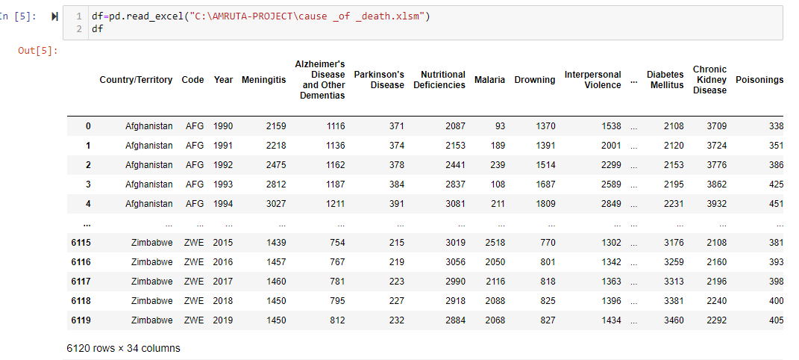

* The above dataset contains 6120 rows and 34 columns.
* The above dataset contains 30 years data of 204 countries.
* Adding a new column named of all the key causes of death given in this dataset. Sorting Top 40 among the observations:

* From the Above table, the "top 40 - Total_no_of_Deaths" belongs to 'China' and 'India' because of the fact "China" and "India" are the most populated countries of the World .

**Top 10 causes of death for countries like India and China**:

* Top 10 causes of death in China

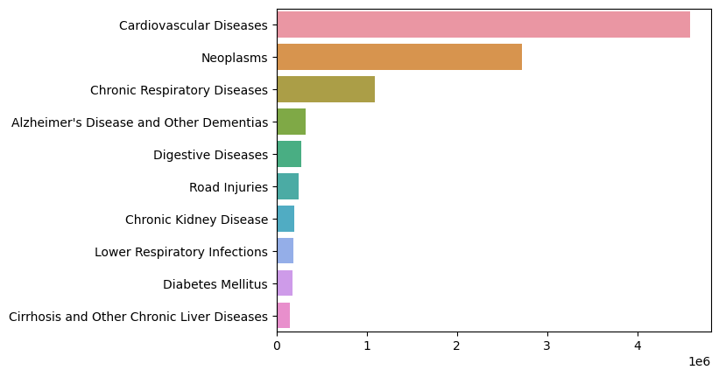

* **Top 10 causes of death in India**

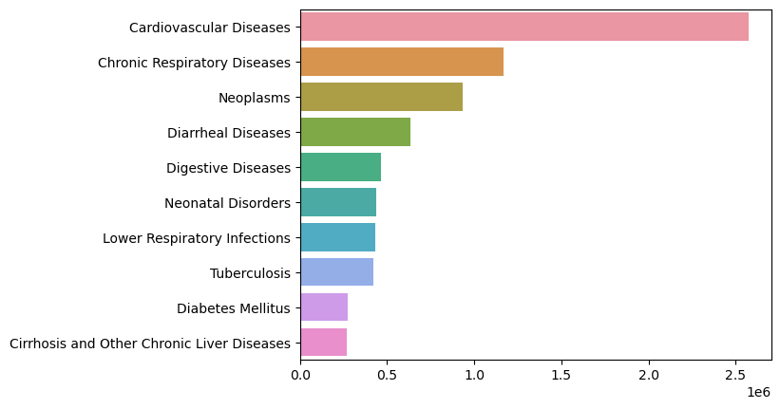

* It can be seen from above two bar plots, cardiovascular diseases are the

leading cause of death globally. Out of 204 countries in the dataset, cardiovascular diseases are a major cause of death for 156 countries.

**Deadliest Year**

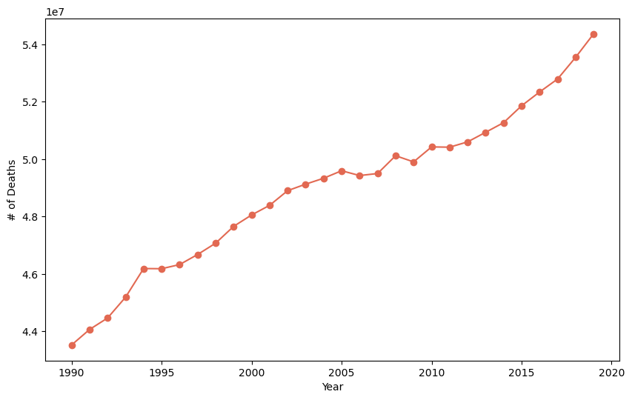

* Deadliest year appears to be 2019 in terms of death counts; however it was due to the increase of the world population each year.

**Cardiovascular diseases**

Cardiovascular disease (CVD) is a term used to refer to the range of diseases which affect the heart and blood vessels. These include hypertension (high blood pressure); coronary heart disease (heart attack); cerebrovascular disease (stroke); heart failure; and other heart diseases.

Top 10 countries which suffered from CVD the most:

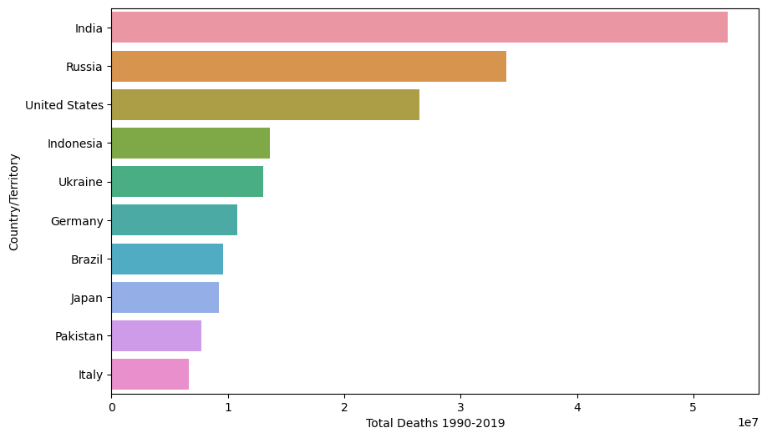

* India has highest number of deaths due to cardiovascular diseases followed by Russia and US.

**HIV/AIDS**

An infection with HIV (human immunodeficiency virus) can lead to AIDS (acquired immunodeficiency syndrome). AIDS results in a gradual and persistent decline and failure of the immune system, resulting in heightened risk of life-threatening infection and cancers.

In most cases, HIV is a sexually transmitted infection. However, HIV can also be transmitted from a mother to her child, during pregnancy or childbirth, or through breastfeeding. Non-sexual transmission can also occur through the sharing of injection equipment such as needles.

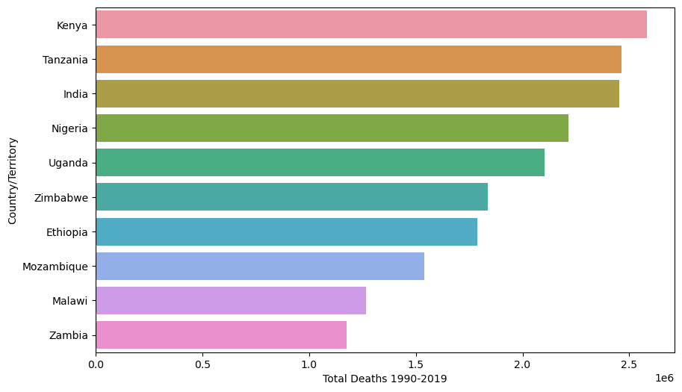

* Across Sub-Saharan Africa the deaths are much higher. Most countries in the South of the region had deaths greater than 1.5 million. In India, the deaths due to HIV/AIDS were nearly 2.5 million.

**Neoplasm**

An abnormal mass of tissue that forms when cells grow and divide more than they should or do not die when they should. Neoplasm may be benign (not cancer) or malignant (cancer). Cancers can arise in many parts of the body -leading to a range of cancer types-and in some cases spread to other parts of the body through the blood and lymph systems.

Top 10 countries which suffered from Neoplasm the most:

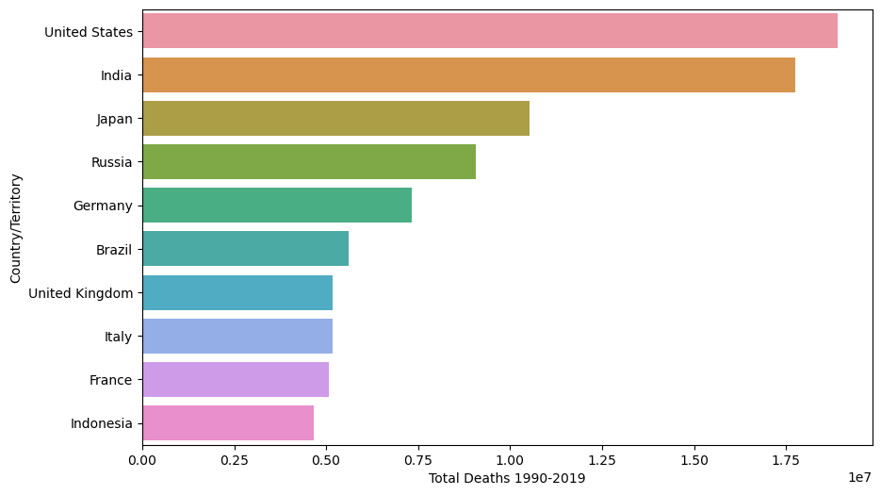

* Cancer is a particularly common cause of death in richer countries where people are less likely to die of infectious diseases and causes of deaths that lead to very early deaths for people in poverty.

**Diarrheal Diseases**

Diarrheal diseases are caused primarily by viral and bacterial pathogens. They are particularly dominant at lower incomes where there is poor access to safe sanitation, drinking water and hygiene facilities. Diarrheal diseases are a leading cause of death in children. According to WHO, each year diarrhoea kills around 525 000 children under five.

* Diarrheal diseases were the fourth leading cause of death in 2019.Overall, we see the highest mortality in Sub -Saharan Africa and South Asia

**Malaria**

Malaria is a disease that is transmitted from person to infected mosquitoes. The bite of an infected Anopheles mosquito transmits a parasite that enters the victim’s blood system and travels into the person’s liver where the parasite reproduces. The parasite causes a high fever that involves shaking chills and pains. In the worst cases malaria leads to coma and death.

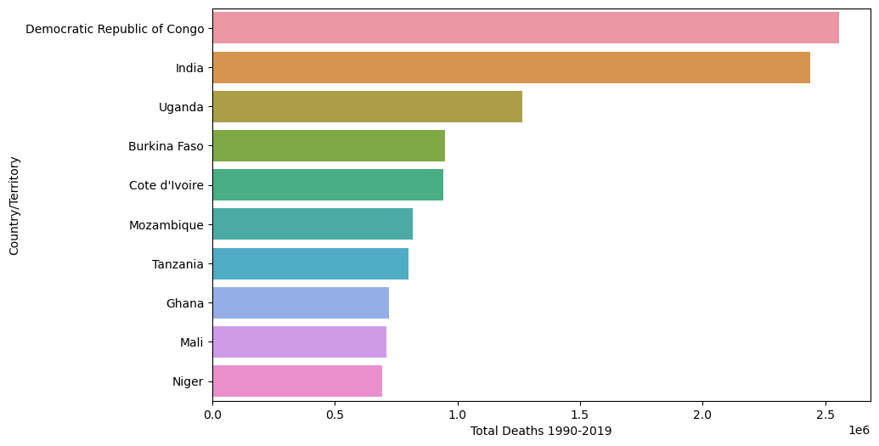

* Africa is the world region that is most affected by malaria in the last 30 years.

* Majority of global deaths from malaria occurred on the African continent. But Africa is also the world region that has achieved most progress: since 2000, deaths have fallen significantly.

**Neonatal Disorders**

Its noun form, neonate, is another word for a new-born. Neonatal infections are primarily bacterial in origin, and include pneumonia, sepsis, and meningitis.

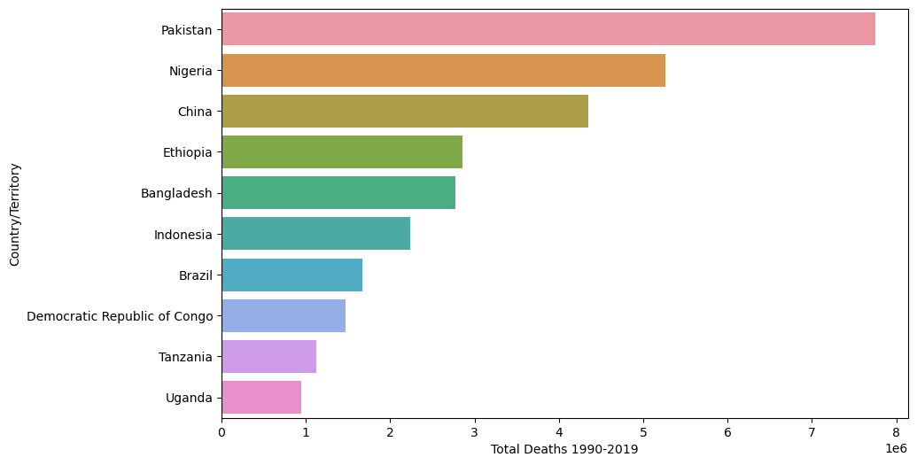

* The highest mortality is seen across Sub-Saharan Africa and Asia.

**Lower Respiratory Infection:**

* China has highest number of deaths due to lower respiratory infections like Pneumonia.
* USA also in top 6 in number of deaths due to lower respiratory.

**Conflict and Terrorism:**

Violent, criminal acts committed by individuals and/or groups who are inspired by, or associated with, designated foreign terrorist organizations or nations (state-sponsored)

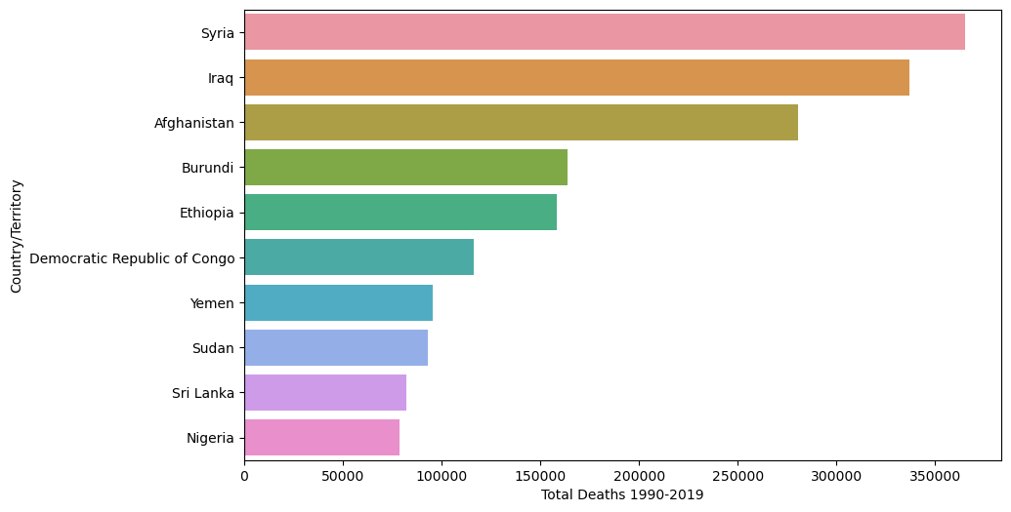

* Most victims of terrorism die in the Middle East, Africa, and South Asia.
* Most are affiliated with well-known terrorist groups, such as Islamic State, Taliban, Boko Haram AI- Shabab.

* 1994 was the year where the deadliest conflicts took place in the world. Bosnian War in Europe may have contributed to it significantly.
* After 2014, deaths due to conflicts and terrorism has been decreasing which is a good sign for the world.

CONCLUSION

* Causes of Death vary significantly between countries: non-communicable diseases dominate in rich countries, whereas infectious diseases remain high at lower incomes.
* Non- communicable diseases (NCDs) not only dominate morality figures at a global level, but also account for most deaths in high income countries.
* There are many diseases which continuously increasing such Neoplasms, HIV/AIDS,Diabetes,Cardiovascular Diseases, Digestive disorder and Alzheimer. Also, there are many disease which are continuously decreasing too such as Acute Hepatitis, Diarrheal Diseases, Nutritional Diseases and Meningitis. Parkinson Diseases seems to be constants till 1990 to 1993 after that no data is present for the same.
* In all the given years i.e., 1990 to 2019, Road accident have taken Maximum lives and the least can death can be seen in Exposure to force of Nature. In case of Death by crime ,self-harm and Accident -> Maximum death have been taken place by Conflict and Terrorism and the second highest death have been recorded by -Interpersonal Violence.
* Rest all other factors of death are under 200k which can be even further minimized all the government and concerned bodies should take reasonable step to ensure that all the areas with maximum deaths can be minimized and proper action should be taken in case of conflict & terrorism and interpersonal violence so that it should be reduced to minimal.